TR-296GK/DX |  | TABLE OF  CONTENTS

 |  |  |  | PAGE
CHAPTER 1
SPECIFICATIONS
1.0 | General . . . . . . . . . . . . . . . . . . . . . . . . . . . . . . . . . . . . . . . . . . . . . . . . . |  |  | 2
1.1 | Transmitter . . . . . . . . . . . . . . . . . . . . . . . . . . . . . . . . . . . . . . . . . . . . . . |  |  | 2
1.2 | Receiver . . . . . . . . . . . . . . . . . . . . . . . . . . . . . . . . . . . . . . . . . . . . . . . . |  |  | 2
CHAPTER 2
OPERATION
2.0 | Introduction . . . . . . . . . . . . . . . . . . . . . . . . . . . . . . . . . . . . . . . . . . . . . . |  |  | 3
2.1 | Control & Connections . . . . . . . . . . . . . . . . . . . . . . . . . . . . . . . . . . . . . |  |  | 3
2.1.1 | Front Panel . . . . . . . . . . . . . . . . . . . . . . . . . . . . . . . . . . . . . . . . . . . . . . |  |  | 3
2.1.2 | Rear Panel . . . . . . . . . . . . . . . . . . . . . . . . . . . . . . . . . . . . . . . . . . . . . . . |  |  | 5
2.1.3 | Frequency Chart . . . . . . . . . . . . . . . . . . . . . . . . . . . . . . . . . . . . . . . . . . |  |  | 6
2.2 | Microphone . . . . . . . . . . . . . . . . . . . . . . . . . . . . . . . . . . . . . . . . . . . . . . |  |  | 7
2.3.1 | Procedure To Receive . . . . . . . . . . . . . . . . . . . . . . . . . . . . . . . . . . . . . . |  |  | 7
2.3.2 | Procedure To Transmit . . . . . . . . . . . . . . . . . . . . . . . . . . . . . . . . . . . . . |  |  | 7
2.4 | Alternate Microphones And Installation . . . . . . . . . . . . . . . . . . . . . . . . |  |  | 7
CHAPTER 3
CIRCUIT DESCRIPTION
3.0 | Introduction . . . . . . . . . . . . . . . . . . . . . . . . . . . . . . . . . . . . . . . . . . . . . . |  |  | 9
3.1 | PLL Circuit . . . . . . . . . . . . . . . . . . . . . . . . . . . . . . . . . . . . . . . . . . . . . . |  |  | 9
3.2 | Receiver Circuit . . . . . . . . . . . . . . . . . . . . . . . . . . . . . . . . . . . . . . . . . . . |  |  | 9
3.3 | Transmitter Modulation Circuit . . . . . . . . . . . . . . . . . . . . . . . . . . . . . . . |  |  | 9
3.4 | Transmitter Amplifier Circuit . . . . . . . . . . . . . . . . . . . . . . . . . . . . . . . . |  |  | 9
CHAPTER 4
ALIGNMENT
4.0 | Required Test Equipment . . . . . . . . . . . . . . . . . . . . . . . . . . . . . . . . . . . |  |  | 11
4.1 | Alignment Procedures . . . . . . . . . . . . . . . . . . . . . . . . . . . . . . . . . . . . . . |  |  | 11
4.1.1 | PLL Alignment . . . . . . . . . . . . . . . . . . . . . . . . . . . . . . . . . . . . . . . . . . . |  |  | 11
4.1.2 | Transmitter Alignment . . . . . . . . . . . . . . . . . . . . . . . . . . . . . . . . . . . . . . |  |  | 12
4.1.3 | Receiver Alignment . . . . . . . . . . . . . . . . . . . . . . . . . . . . . . . . . . . . . . . . |  |  | 13
CHAPTER 5
MAINTENANCE
5.0 | Precautions . . . . . . . . . . . . . . . . . . . . . . . . . . . . . . . . . . . . . . . . . . . . . . |  |  | 16
5.1 | Periodic Inspection . . . . . . . . . . . . . . . . . . . . . . . . . . . . . . . . . . . . . . . . |  |  | 16
5.2 | Fuse Replacement . . . . . . . . . . . . . . . . . . . . . . . . . . . . . . . . . . . . . . . . . |  |  | 16
CHAPTER 6
DIAGRAMS AND PART LIST
6.0 | PCB Layout & Part List . . . . . . . . . . . . . . . . . . . . . . . . . . . . . . . . . . . . |  |  | 17
TR-296GK/DX |  |  | CHAPTER 1  SPECIFICATIONS

1.0 GENERAL
Model | TR-296GK / TR-296DX (B),(C)
Frequency Range | 26.965 - 27.405MHz.
Emission Modes | AM/USB/LSB
Frequency Control | Phase Lock Loop (PLL) synthesizer.
Frequency Tolerance | ± 0.005 %.
Frequency Stability | ± 0.001 %.
Operating Temperature Range | -30°C to +50°C.
Microphone | Plug-in dynamic; with push-to-talk switch and coiled cord.
Input Voltage | 13.8V DC nominal ±15%.
Current Drain: Transmit (AM full mod.) | <3.5A.
Current Drain: Receiver (Squelched) | <0.5A.
(Max. audio output) | <1.0A.
Antenna Connector | UHF, SO239.
Dimensions | 2-3/8”(H) x 7-7/8”(W) x 9-1/4”(D).
Weight | 5 lb.
1.1 TRANSMITTER
RF Power Output | AM : 4W ; USB/LSB : 12W PEP
RF Transmit Modes | AM/USB/LSB
Modulation | High and low level Class B, Amplitude Modulation: AM and SSB.
Spurious Emissions | -55 dB.
Carrier Suppression | -55 dB.
Audio Frequency Response | 300 to 2500 Hz
Antenna Impedance | 50 Ohms.
Output Indicators | Meter shows relative RF output power, signal strength and SWR. Transmit LED glows red when transmitter is in operation.
1.2 RECEIVER
Sensitivity For 10dB S/N (AM) | <0.5 μV.
Sensitivity For 10dB S/N (SSB) | <0.25 μV.
IF Frequency | AM: 10.695 MHz 1st IF, 455 KHz 2nd IF.
Image Rejection | -65 dB.
Adjacent Channel Selectivity | -60 dB.
RF Gain Control | 45 dB adjustable for optimum signal reception.
Automatic Gain Control (AGC) Figure Of Merit | 100 mV for 10 dB Change in Audio Output.
Squelch | Adjustable; threshold less than 0.5 μV.
Noise Blanker | RF type.
Audio Output Power | 4 watts into 8 Ohms.
Audio Frequency Response | AM and SSB: 300 to 2500 Hz.
Built-in Speaker | 8 Ohms, 5 Watts.
External Speaker (Not Supplied) | 8 Ohms; disables internal speaker when connected.
(SPECIFICATIONS SUBJECT TO CHANGE WITHOUT NOTICE)

TR-296GK/DX |  | CHAPTER 2  OPERATION

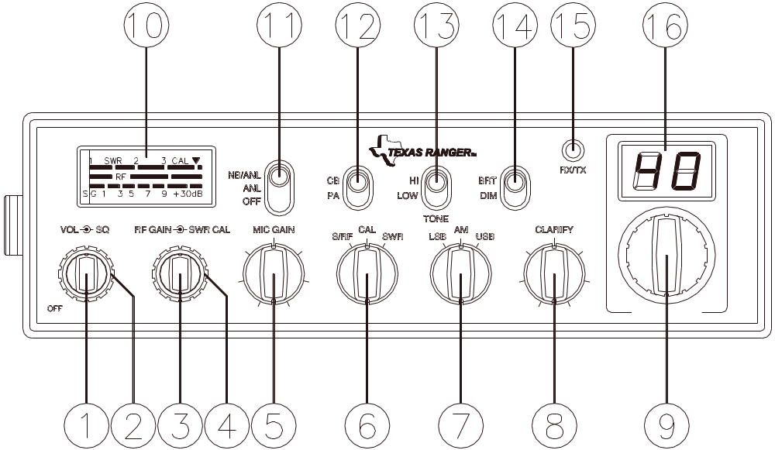

Figure 2-1 Front Panel

2.0 INTRODUCTION
This section explains the basic operating procedures for the TEXAS RANGER TR-296GK / TR-296DX mobile transceiver.

2.1 CONTROLS AND CONNECTIONS

2.1.1 FRONT PANEL
Refer to the above Figure 2-1 for the location of the following controls.

1. ON/OFF VOLUME CONTROL
Turn clockwise to apply power to the radio and to set the desired listening level.

2. SQUELCH CONTROL
This control is used to control or eliminate receiver background noise in the absence of an incoming signal. For maximum receiver sensitivity, it is desired that the control be adjusted only to the point where the receiver background noise is eliminated. Turn fully counter-clockwise, then slowly clockwise until the receiver noise disappears. Any signal to be received must now be slightly stronger than the average received noise. Further clockwise rotation will increase the threshold level which a signal must overcome in order to be heard. Only strong signals will be heard at a maximum clockwise setting.

3. RF GAIN CONTROL
This control is used to reduce the gain of the receive amplifier under strong signal conditions.

4. SWR CAL CONTROL
This SWR CAL control allows the user to calibrate the SWR meter.

5. MIC GAIN CONTROL
Adjusts the microphone gain in the transmit and PA modes. This controls the gain to the extent that full talk power is available several inches away from the microphone. In the Public Address (PA) mode, the control functions as the volume control.

6. S-RF/CAL/SWR SWITCH
In the S-RF position, the meter swings proportionally to the strength of the received signal. When transmitting, the meter indicates relative RF output power. When in the CAL position, the SWR meter can be calibrated by adjusting the SWR CAL control. When in the SWR position, the Standing Wave Ratio is measured.

7. MODE CONTROL
This control allows you to select one of the following operating modes: LSB/AM/USB.

8. CLARIFY CONTROL
Allows tuning of the receive frequency above or below the channel frequency by up to 1.5 KHz. Although this control is intended primarily to tune in SSB signals, it may be used to optimize AM signals.

9. CHANNEL SELECTOR
This control is used to select a desired transmit and receive channel.

10. FRONT PANEL METER
The Front Panel Meter allows the user to monitor signal strength, RF output power and SWR level.

11. NB/ANL/OFF SWITCH
In the ANL position, the automatic noise limiter in the audio circuits is activated. When the switch is placed in the NB/ANL position, the RF noise blanker is also activated. The noise blanker is very effective in eliminating repetitive impulse noise such as ignition interference.

12. CB/PA SWITCH
The CB is a normal operation of the radio. In the CB position, the PA function is disabled and the unit will transmit and receive on the speaker that is connected. In the PA position, the radio acts as a public address amplifier. Your voice will come out of the speaker that have plugged in to the PA. SP. jack on the rear panel. The radio does not operate when you are in the PA mode.

13. TONE HI/LO SWITCH
This switch is used to shape the tone of the received signal. In LO position, bass is increased and in HI position, treble is increased.

14. BRIGHT/DIM SWITCH
This switch controls the level of brightness for the meter lamp and channel display LED.

15. TX/RX LED
The red LED indicates the unit is in the transmit mode. The green LED indicates the unit is in the receive mode.

16. CHANNEL DISPLAY
The channel display indicates the current selected channel.

2.1.2 REAR PANEL
Figure 2-2 represent the location of the following connections:

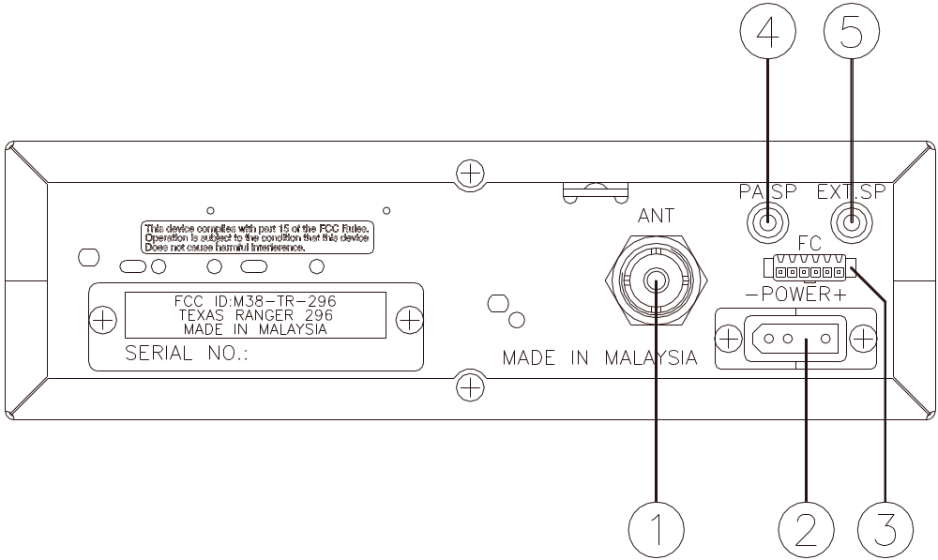

Figure 2-2 Rear Panel

1. ANTENNA
This jack accepts 50 ohms coaxial cable with a PL-259 type connector.

2. POWER
This connector accepts 13.8V DC power cable with built-in fuse. The power cord provided with the radio has a black and red wire. The black goes to negative and the red goes to positive.

3. FREQUENCY COUNTER CONNECTOR
This F. C. connector is used for an external frequency counter which indicates the frequency of the selected channel.

4. PA. SP.
This jack is for PA operation. Before operating, you must first connect a PA speaker (8 ohms, 4W) to this jack.

5. EXT. SP.
This jack accepts 4 to 8 ohms, 5 watts external speaker. When the external speaker is connected to this jack, the built-in speaker will be disabled.

2.1.3 FREQUENCY CHART

CHANNEL | CHANNEL FREQUENCY |  | CHANNEL | CHANNEL FREQUENCY
1 | 26.965 | MHz | 21 | 27.215 | MHz
2 | 26.975 | MHz | 22 | 27.225 | MHz
3 | 26.985 | MHz | 23 | 27.255 | MHz
4 | 27.005 | MHz | 24 | 27.235 | MHz
5 | 27.015 | MHz | 25 | 27.245 | MHz
6 | 27.025 | MHz | 26 | 27.265 | MHz
7 | 27.035 | MHz | 27 | 27.275 | MHz
8 | 27.055 | MHz | 28 | 27.285 | MHz
9 | 27.065 | MHz | 29 | 27.295 | MHz
10 | 27.075 | MHz | 30 | 27.305 | MHz
11 | 27.085 | MHz | 31 | 27.315 | MHz
12 | 27.105 | MHz | 32 | 27.325 | MHz
13 | 27.115 | MHz | 33 | 27.335 | MHz
14 | 27.125 | MHz | 34 | 27.345 | MHz
15 | 27.135 | MHz | 35 | 27.355 | MHz
16 | 27.155 | MHz | 36 | 27.365 | MHz
17 | 27.165 | MHz | 37 | 27.375 | MHz
18 | 27.175 | MHz | 38 | 27.385 | MHz
19 | 27.185 | MHz | 39 | 27.395 | MHz
20 | 27.205 | MHz | 40 | 27.405 | MHz

2.2 MICROPHONE

The receiver and transmitter are controlled by the push-to-talk switch on the microphone. Press the switch and the transmitter is activated, release switch to receive. When transmitting, hold the microphone two inches from the mouth and speak clearly in a normal voice. The radio comes complete with a low impedance (500 ohm) dynamic microphone. For installation instructions of the microphone, see section 2.4 “ALTERNATE MICROPHONES AND INSTALLATION”.

2.3 OPERATION

2.3.1 PROCEDURE TO RECEIVE
1. Be sure that power source, microphone and antenna are connected to the proper connectors before going to the next step.

2. Turn unit on by turning VOL knob clockwise on transceiver.

3. Set the VOL to a comfortable listening level.

4. Set the MODE switch to the desired mode.

5. Listen to the background noise from the speaker. Turn the SQ knob slowly clockwise until the noise just disappears. The SQ is now properly adjusted. The receiver will remain quiet until a signal is actually received. Do not advance the control too far or some of weaker signals will not be heard.

6. Set the CHANNEL selector switch to the desired channel.

7. Set the RF GAIN control fully clockwise for maximum receive gain.

8. Adjust the CLARIFY control to clarify the SSB signals or to optimize AM signals.

2.3.2 PROCEDURE TO TRANSMIT
1. Select the desired channel of transmission.

2. Set the MIC GAIN control fully clockwise.

3. If the channel is clear, depress the push-to-talk switch on the microphone and speak in a normal voice.

2.4 ALTERNATE MICROPHONES AND INSTALLATION

For best results, the user should select a low impedance dynamic type microphone or a transistorized microphone. Transistorized type microphones have a low output impedance characteristic. The microphones must be provided with a five-lead cable. The audio conductor and its shielded lead comprise two of the leads. The third lead is for receive control, the fourth is for grounding and fifth is for transmit control. The microphone should provide the functions shown in schematic below (Figure 2-3).

5 WIRE MIC CABLE

 | Pin Number | Mic Cable Lead
 | 1 | Audio Shield
 | 2 | Audio Lead
 | 3 | Receive Control
 | 4 | Grounding
 | 5 | Transmit Control

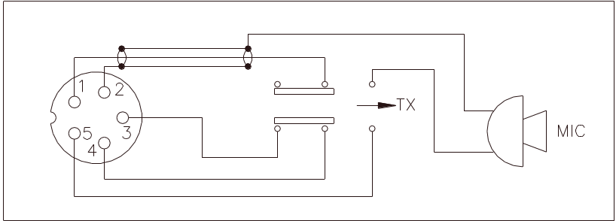

Figure 2-3 Transceiver Microphone Schematic

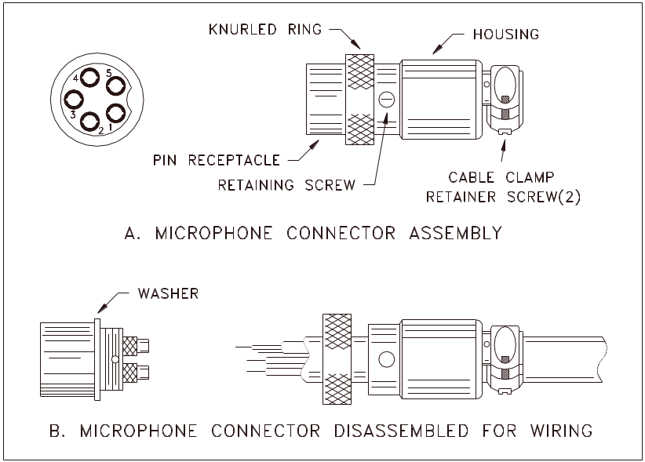

Figure 2-4 Microphone Plug Wiring

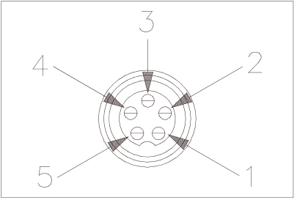

Figure 2-5 Microphone plug pin numbers viewed from rear of pin receptacle.

TR-296GK/DX |  | CHAPTER 3  CIRCUIT DESCRIPTION

3.0 INTRODUCTION
This section explains the technical theory of operation for the TR-296GK / TR-296DX mobile transceiver.

3.1 PLL CIRCUIT
The Phase Lock Loop (PLL) circuit is responsible for developing the receiver’s first local oscillator signal and the transmitter’s exciter signal. The PLL circuit consists primarily of IC1, IC2, TR20, TR29 and TR30. The PLL circuit is programmed by the rotary channel switch GPS-0668. The GPS-0668 communicates the correct binary data information to the programmable divider inside of IC1. IC1 then controls the VCO (Voltage Controlled Oscillator) to oscillate on the correct frequency. This signal is fed either into the receiver’s first mixer (for receive operation) or the transmitter’s mixer (for transmit operation).

3.2 RECEIVER CIRCUIT
The incoming receive signal comes into the radio via the antenna and into the first RF amplifier, TR14. The RF signal is fed into the mixer, TR15 and then into the AM IF section of the receiver (depending on the mode of operation). The signal is then detected by either the AM detector or product detector and then fed to the audio amplifier section of the receiver and finally out to the speaker.

3.3 TRANSMITTER MODULATION CIRCUIT
(i) The transmitter modulation circuit modulates the low level RF signal from the PLL exciter circuit with the user’s audio voice signal from the microphone. The audio from the microphone is then amplified and fed into the balanced modulator circuit.

(ii) If the transceiver is in the AM mode, the AF amplifier controls the gain of the last RF amplifier which produces a true AM signal.

(iii) If the transceiver is in the SSB mode, the audio signal is mixed with 7.800MHz oscillator in IC3.

3.4 TRANSMITTER AMPLIFIER CIRCUIT
The transmitter takes the basic exciter signal from the TX mixer and amplifies it through a series of amplifiers consisting of TR39, TR38 and TR36 where it is sent out to the antenna connector.

TR-296GK/DX BLOCK DIAGRAM
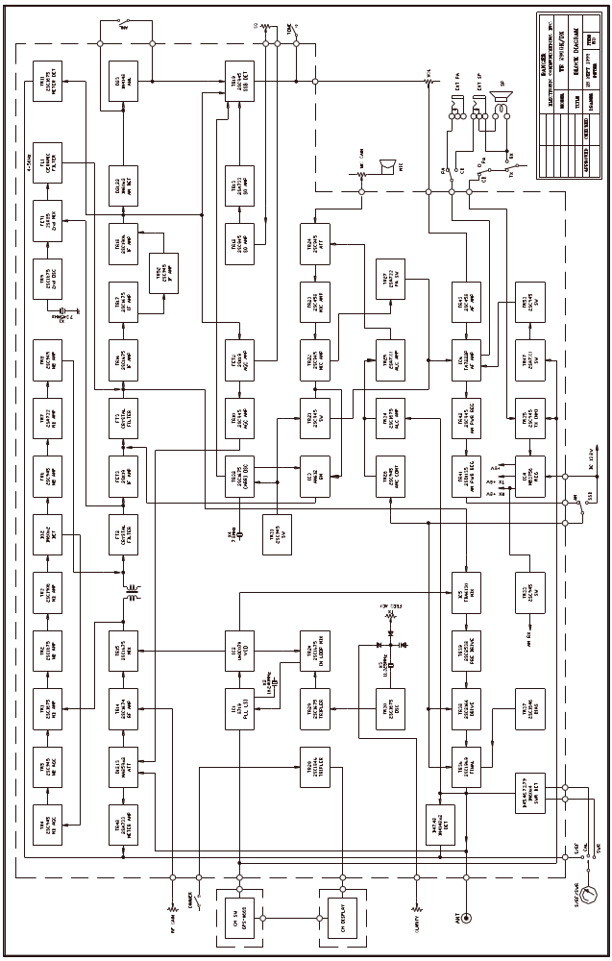
TR-296GK/DX |  | CHAPTER 4  ALIGNMENT

4.0 REQUIRED TEST EQUIPMENT

① DC Power Supply (13.8VDC, 10A)  ② RF Wattmeter (25~60 MHz, 25W)  ③ Multimeter  ④ Automatic Modulation Meter  ⑤ Audio Signal Generator | ⑥ Frequency Counter (100 MHz)  ⑦ RF Signal Generator (100 MHz)  ⑧ Automatic Distortion Meter  ⑨ Oscilloscope (50 MHz)  ⑩ Sinad Meter

4.1 ALIGNMENT PROCEDURES
This transceiver has been aligned at the factory and does not require any adjustments at installation. The required test equipment listed are used for the test setup or alignment shown in Figure 4-1 Transmitter Test Setup and Figure 4-2 Receiver Test Setup. These test setup are used in part or total during the following adjustments and refer to Figure 4-3 for adjustment location.

4.1.1 PLL ALIGNMENT

ITEM | U.U.T. SETTING | ADJUST POINT | MEASUREMENT
VCO Voltage | Set radio to CH 1, AM RX mode.  Clarify setting in 12 o’clock position.  Connect DC Voltmeter to TP9 (R207).  Connect Oscilloscope to TP10 (R101).  Connect Oscilloscope to TP1 (R106). | L19  L21  L20 | 2.5 VDC ± 0.1  CH 1 & CH 40 Max. Output and Balance.
AM Frequency | Set radio to CH 1, AM RX mode.  Connect frequency counter to TP1 (R106). | L23 | 34.76500 MHz + 20 Hz
LSB Freq. | Set radio to CH 1, LSB RX mode.  Connect frequency counter to TP1 (R106). | L22 | 34.76350 MHz + 20 Hz
USB Freq. | Set radio to CH 1, USB RX mode.  Connect frequency counter to TP1 (R106). | L59 | 34.76650 MHz + 20 Hz
TX Frequency | Set radio to CH 1, AM TX mode.  Connect frequency counter to TP1 (R106). | VR5 | 34.76500 MHz + 20 Hz
AM TX Freq. | Set radio to CH 19, AM TX mode.  Set Mic Gain fully counter clockwise. | L31 | 27.18500 MHz + 20 Hz
LSB TX Freq. | Set radio to CH19, LSB TX mode.  Set Mic Gain fully clockwise.  AF signal 25 mV, 1 KHz to microphone. | L30 | 27.18400 MHz + 20 Hz
USB TX Freq. | Set radio to CH19, USB TX mode.  Set Mic Gain fully clockwise.  AF signal 25 mV, 1 KHz to microphone. | CT2 | 27.18600 MHz + 20 Hz

4.1.2 TRANSMITTER ALIGNMENT

ITEM | U.U.T. SETTING | ADJUST POINT | MEASUREMENT
BIAS Current | Set radio to CH 19, USB TX mode. MOD off.  Connect current meter to TP8 (+) and green lead wire (-).  Connect current meter to TP7 (+) and violet lead wire (-). | VR9  VR8 | 30 mA  50 mA
AM TX Power | Set radio to CH 19, AM TX mode.  Connect RF power meter to antenna jack.  MOD off. | L48, L47, L46, L45,  L38, L36  L38  VR10 | RF Power Output MAX  Balance Power between CH 1 and CH 40.  4W.
SSB ALC | Set radio to CH 19, USB TX mode.  Set Mic Gain fully clockwise.  AF signal 25 mV, 1 KHz to microphone. | VR11 | 12 W.
SSB Carrier Balance | Set radio to CH 19, USB TX mode.  Connect Oscilloscope to L44 (TR39C).  Mic Gain off. | VR4 | Spurious Emission to minimum.
AM  Modulation | Set radio to CH 19, AM TX mode.  Set Mic Gain fully clockwise.  AF signal 30 mV, 1 KHz to microphone. | VR7 | 95%
RF Power Meter | Set radio to CH 19, AM TX mode.  MOD off. | VR6 | Adjust RF Power meter needle until it is in-between the green and red bar on PWR scale.

4.1.3 RECEIVER ALIGNMENT

ITEM | SETTINGS | ADJUST POINT | MEASUREMENT
AM Sensitivity | Set radio to CH 20, AM RX MODE.  Clarify setting in 12 o’clock.  Set RF gain fully clockwise.  Set SQ fully counter clockwise.  Set VOL control to 2 o’clock.  Set NB/ANL to OFF position.  Connect RF SG to antenna jack.  Frequency 27.205 MHz, Level 1 uV.  MOD 30%, 1KHz.  Set radio to CH 40 AM mode.  RF SG setting 27.405 MHz.  Set radio to CH 1 AM mode.  RF SG setting 26.965 MHz. | L13, L15, L3, L4, L5,  L6, L7, L8,  L9, L10 | Audio output > 2V  S/N > 10 dB
USB Sensitivity | Set radio to CH 20, USB RX mode. MOD off.  Set VOL control fully clockwise.  RF SG setting 27.206 MHz, Level 1 uV. | L12, L14 | Audio output > 4.5V  S/N > 20 dB
LSB Sensitivity | Set radio to CH 20, LSB RX mode. MOD off.  VOL control fully clockwise.  RF SG setting 27.204 MHz, Level 1 uV. | L12, L14 | Audio output > 4.5V  S/N > 20 dB
NB/ANL Adjust | Set radio to CH 20, AM RX mode.  RF SG setting 27.205 MHz, Level 100 uV.  MOD 30%, 1KHz.  Set NB/ANL/OFF switch to NB/ANL.  Connect Voltmeter to D2 (Cathode). | L1, L2 | DC voltage to max.  ( >1.5V )
AM Squelch | Set radio to CH 20, AM RX mode.  Set SQ control at fully clockwise.  RF SG setting 27.205 MHz, Level 1 mV.  MOD 30%, 1KHz. | VR3 Slowly | Adjust very slowly until quelch just open
AM S/RF Meter | Set radio to CH 20 AM RX mode. MOD off.  Set S-RF/CAL/SWR switch to S/RF position.  RF SG setting 27.205 MHz, Level 100 uV. | VR1 | Meter needle to S9 on the S scale
SSB S/RF Meter | Set radio to CH 20, USB RX mode. MOD off.  Set S-RF/CAL/SWR switch to S/RF position. RF SG setting 27.206 MHz, Level 100 uV | VR2 | Meter needle to S9 on the S scale

Figure 4-1 Transmitter test setup

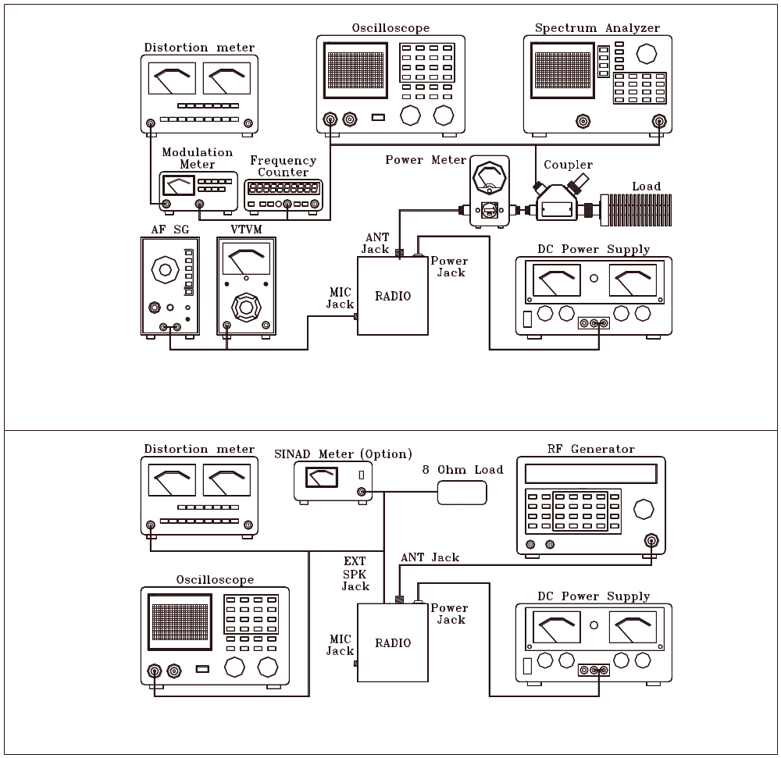

Figure 4-2 Receiver test setup

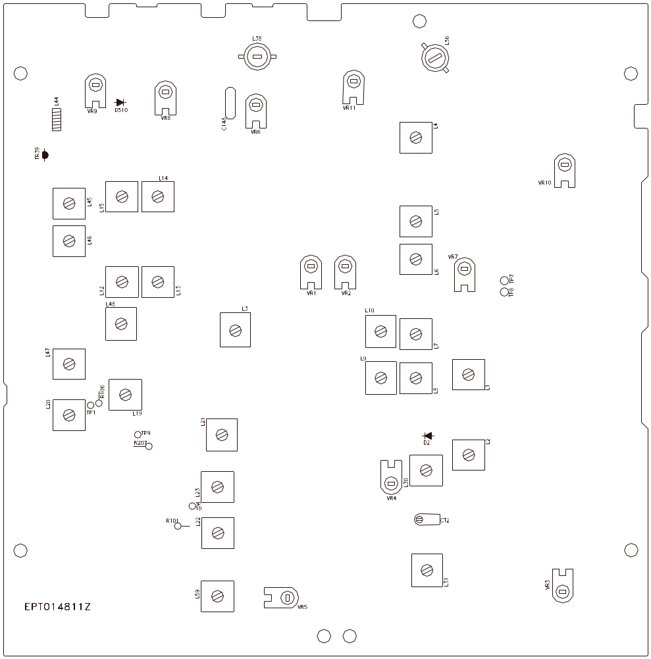

Figure 4-3 Main PCB Adjustment Location

TR-296GK/DX |  | CHAPTER 5  MAINTENANCE

5.0 PRECAUTIONS
The inherent quality of the solid-state components used in this transceiver will provide many years of continuous use. Taking the following precautions will prevent damage to the transceiver.

(i) Never key the transmitter unless an antenna or suitable dummy load is connected to the antenna receptacle.

(ii) Ensure that the input voltage does not exceed 16 VDC or fall below 11 VDC.

(iii) During alignment, do not transmit for more than 10 seconds at a time. Transmitting over long periods can cause heat built-up and cause transmitter damage.

5.1 PERIODIC INSPECTION
This unit is aligned at the factory to deliver maximum performance. However, continued performance cannot be expected without periodic inspection and maintenance. Important points to be checked regularly are as follows;

Check Item | Action
Whip antenna (option) | If cracked or broken, replace it.
Coaxial cable | If sheath is cracked, seal with vinyl tape. If immersed with water, install new coaxial cable.
Coaxial & power plug connections | If loosened, reconnect. If corroded, clean contacts.
Battery connection | If corroded, clean power terminals.
Ground terminal | If corroded, clean terminal.

5.2 FUSE REPLACEMENT
To protect the equipment from serious damage, a fuse is provided on the power supply lines. The fuse protect against overvoltage / reverse polarity or internal fault of the equipment. If the fuse has blown, first find out the cause of the trouble before replacing it. A fuse rated for more than 4A should not be used, since it may permanently damage the equipment. Damage due to overfusing is not covered by the warranty.

TR-296GK/DX |  | CHAPTER 6  DIAGRAMS & PARTS LIST

6.0 GENERAL
Information on most electrical and mechanical parts is included in the parts list. The reference designators are in alphanumeric order.

6.1 ORDERING REPLACEMENT PARTS
Parts orders should be referred to the parts department at:

• Ranger Communications, Inc.
401 W. 35th Street
National City, CA 91950

Tel: 800-446-5778
Fax: 619-426-3788

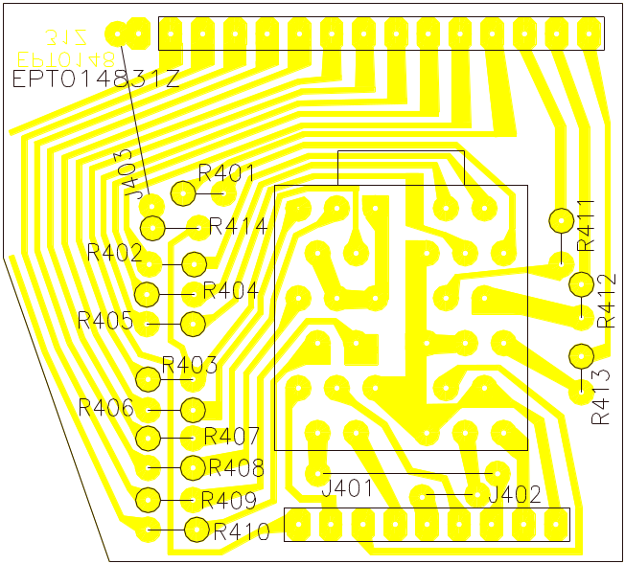

PART LIST:

TR-296GK/DX ROTARY SW. P.C.B

ITEM | REFERENCE NUMBER | RANGER PART NUMBER | DESCRIPTION
1 |  | EPT014831Z | ROTARY SW. P.C.B
2 | ROTARY SW PCB | EWRT32059S | ROTARY SW
3 | R401-R414 | RCU146814Z | 680 ohm 1/4W
4 | J402 | WX01070705 | JUMPER WIRE
5 | J401 | WX01070715 | JUMPER WIRE
6 | J403 | WX01070712 | JUMPER WIRE

REMARK:
SOLDER SIDE (BLUE)

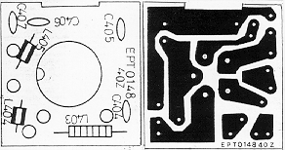

PART LIST:

TR-296GK/DX MIC P.C.B

ITEM | REFERENCE NUMBER | RANGER PART NUMBER | DESCRIPTION
1 |  | EPT014840Z | MIC P.C.B
2 | C404-C407 | CC0501027L | 0.001μF 50V
3 | L404,L405 | ECBAD18558 | BEAD COIL

REMARK:
LEFT: COMPONENT SIDE
RIGHT: SOLDER SIDE

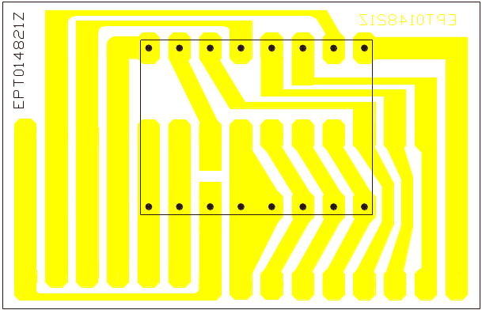

PART LIST:

TR-296GK/DX CH DISPLAY P.C.B

ITEM | REFERENCE NUMBER | RANGER PART NUMBER | DESCRIPTION
1 |  | EPT014821Z | CH DISPLAY P.C.B
2 | CH DISPLAY PCB | EX03N40003 | LED DISPLAY

REMARK:
SOLDER SIDE (BLUE)

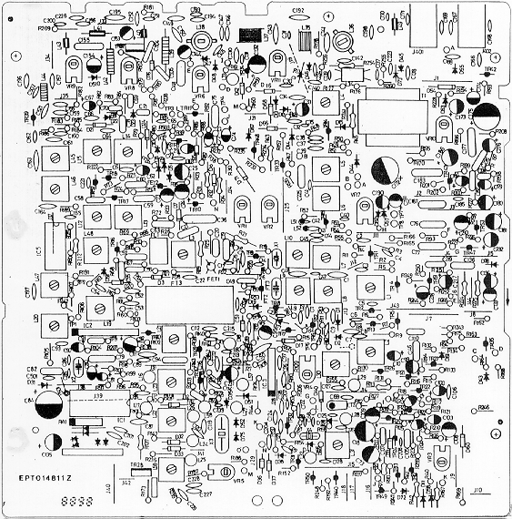

TR-296GK/DX MAIN PCB.

REMARK:
COMPONENT SIDE

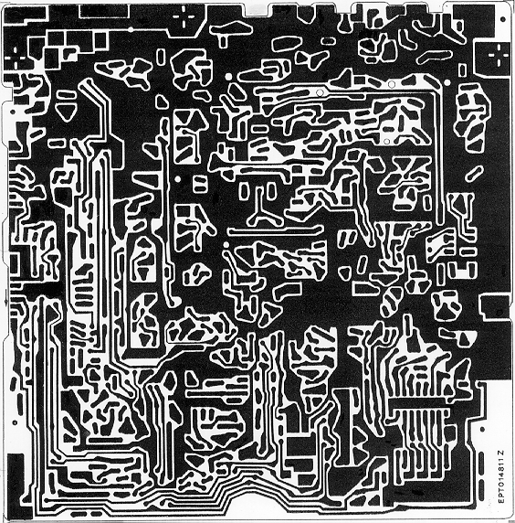

TR-296GK/DX MAIN PCB.

REMARK:
COPPER SIDE

PART LIST
TR-296GK/DX MAIN PCB

REFERENCE  NUMBER | RANGER  PART NO. | DESCRIPTION
 | EPT014813Z | MAIN P.C.B
R208 | RCU141094Z | 1 Ω 1/4W
R68 | RCU143394Z | 3.3 Ω 1/4W
R181,183 | RCU141004Z | 10 Ω 1/4W
R122 | RCU141504Z | 15 Ω 1/4W
R62 | RCU142204Z | 22 Ω 1/4W
R9,76,198 | RCU146804Z | 68 Ω 1/4W
R38,51,52,55,105,108,139.186,188,190,241,501,179,189,242. | RCU141014Z | 100 Ω 1/4W
R75,177 | RCU141514Z | 150 Ω 1/4W
R61 | RCU141814Z | 180 Ω 1/4W
R25,37,60,70,143,150,209,5 | RCU142214Z | 220 Ω 1/4W
R8,15,31,191,233,184,176,3 | RCU143314Z | 330 Ω 1/4W
R255 | RCU143914Z | 390 Ω 1/4W
R4,57,67,117,256 | RCU144714Z | 470 Ω 1/4W
R111,164,228,257 | RCU145614Z | 560 Ω 1/4W
R94,199 | RCU146814Z | 680 Ω 1/4W
R59,232 | RCU148214Z | 820 Ω 1/4W
R20,24,33,36,48,49,  56,87,90,92,104,115,121,138,140,146,211,153,168,170,173,194,  195,222,503 | RCU141024Z | 1K Ω 1/4W
R30,185,205 | RCU141224Z | 1.2K Ω 1/4W
R26,64,95,74,112,135,165 | RCU141524Z | 1.5K Ω 1/4W
R27 | RCU141824Z | 1.8K Ω 1/4W
R41,50,97,102,103,  120,141,175,259 | RCU142224Z | 2.2K Ω 1/4W
R7,91,144,187,210 | RCU142724Z | 2.7K Ω 1/4W
R47,109,227 | RCU143924Z | 3.9K Ω 1/4W
R17,28,58,88,116,134,162,197,201,235,166,1 | RCU143324Z | 3.3K Ω 1/4W
R46,72,196 | RCU144724Z | 4.7K Ω 1/4W
R18,40,124 | RCU145624Z | 5.6K Ω 1/4W
R69,100,200 | RCU146824Z | 6.8K Ω 1/4W
R44,123,147,148,160,236 | RCU148224Z | 8.2K Ω 1/4W
R11,12,14,16,19,22,  53,65,78,89,93,237,  119,126,131,142,145,152,154,157,158,161,  203,223,238,239,132,23 | RCU141034Z | 10K Ω 1/4W
R98,39 | RCU141234Z | 12K Ω 1/4W
R66,79 | RCU141534Z | 15K Ω 1/4W
R2,149,159 | RCU141834Z | 18K Ω 1/4W
R125,128,151,156,163,202,174 | RCU142234Z | 22K Ω 1/4W
R114 | RCU142734Z | 27K Ω 1/4W
R73,96,129,99 | RCU143334Z | 33K Ω 1/4W
R6,118,133,226 | RCU144734Z | 47K Ω 1/4W
R155 | RCU145634Z | 56K Ω 1/4W
R81,84 | RCU146834Z | 68K Ω 1/4W
R82,83 | RCU141044Z | 100K Ω 1/4W
R110 | RCU141544Z | 150K Ω 1/4W
R35,54 | RCU141844Z | 150K Ω 1/4W
R206 | RCU142744Z | 270K Ω 1/4W
R13,85 | RCU144744Z | 470K Ω 1/4W
R234 | RCU145644Z | 560K Ω 1/4W
R80,127,258 | RCU141054Z | 1M Ω 1/4W
R167 | RCM143914A | 390Ω 1/4W
R77 | RCM143324A | 3.3K Ω 1/4W
R21 | RCM141014B | 100 Ω 1/4W
R29,254 | RCM141514B | 150 Ω 1/4W
R42,137 | RCM141024B | 1K Ω 1/4W
R45 | RCM141524B | 1.5K Ω 1/4W
R43 | RCM141824B | 1.8K Ω 1/4W
R34,224 | RCM143324B | 3.3K Ω 1/4W
R32 | RCM143924B | 3.9K Ω 1/4W
R113 | RCM141034B | 10K Ω 1/4W
R225 | RCM141044B | 100K Ω 1/4W
R107-D53 | RCP145604Z | 56 Ω 1/4W
R106 | RCP141514Z | 150 Ω 1/4W
R212 | RCP141524Z | 1.5K Ω 1/4W
R207 | RCP142724Z | 2.7K Ω 1/4W
R101 | RCP141034Z | 10K Ω 1/4W
R86 | RCP144734Z | 47K Ω 1/4W
R178 | RCP121034Z | 10K Ω 1/4W
R10 | RCP141044Z | 100K Ω 1/4W
R193 | RCP102214Z | 220 Ω 1W
R180 | RCP122714Z | 270 Ω 1/2W
R169 | RCP124704Z | 47 Ω 1/2W
R182 | RCP123314Z | 330 Ω 1/2W
RA1 | CCS0573002 | C/ARRAY 0.001uF 5P
C145 | CC0500301A | 3PF 50WV
C130 | CC0500101A | 1PF 50WV
C41,47,163 | CC0500201A | 2PF 50WV
C38 | CC0500401A | 4PF 50WV
C48,65,116,125 | CC0500501A | 5PF 50WV
C98 | CC0500802A | 8PF 50WV
C131 | CC0501004A | 10PF 50WV
C31 | CC0501204A | 12PF 50WV
C68 | CC0501504A | 15PF 50WV
C142 | CC0502704A | 27PF 50WV
C1,128,85 | CC0503304A | 33PF 50WV
C26,86 | CC0503904A | 39PF 50WV
C89,147,162,207,502 | CC0504704A | 47PF 50WV
C127,141 | CC0508204A | 82PF 50WV
C88 | CC0501015A | 100PF 50WV
C9 | CC0508204G | 82PF 50WV
C15,17,45 | CC0501015G | 100P 50WV
C143 | CC0501815G | 180PF 50WV
C123,64,66 | CC0502215G | 220PF 50WV
C156 | CC0502715G | 270PF 50WV
C146,150,152 | CC0503915G | 390PF 50WV
C117,212 | CC0504715G | 470PF 50WV
C161 | CC0503315G | 330PF 50WV
C213 | CC0500602D | 6PF 50WV
C149 | CC0501015D | 100PF 50WV
C122 | CC0501215D | 120PF 50WV
C158 | CC0501815L | 180PF 50WV
C139,137 | CC0500591L | 0.5PF 50WV
C236,237 | CC0503315L | 330PF 50WV
C155,192,195,111 | CC0251047L | 0.1uF 25WV
C93,96,97,106,112,  113,114,119,120,126,129,164,198,199,40 | CC0501037L | 0.01uF 50WV
C8,11,14,35,37,39,42,5,43,44,170,185,208,201,202 | CC0501027L | 0.001uF  50WV
C3,4,6,7,16,22,27,50,51,52,53,54,61,83,  87,124,196,197,204,  215,227,229,2 | CC0502237L | 0.022uF  50WV
C188 | CC0504737L | 0.047uF  50WV
C32,34,140,151,171,  157,160,165,169,200,223,224,30,138,167,  166,168,159 | CC0504725T | 0.0047uF 50WV
C194 | CCM254737I | 0.047uF  50WV
C36,77,79,82,177,183,187,136 | CM0501045Z | 0.1uF 50WV
C76,78,107,110,118 | CM0501035Z | 0.01uF 50WV
C70,71,178 | CM0501024Z | 0.001uF  50WV
C21,46,49,55,58,182,63 | CM0502235Z | 0.022uF  50WV
C19,56,59,60,75,225,235,91,94 | CM0504735Z | 0.047uF  50WV
C69,105 | CM0502225Z | 0.0022uF  50WV
C102 | CM0504725Z | 0.0047uF 50WV
C132 | CE0502257H | 2.2uF 50V
C23,25,108,135,230,  231 | CE050474Z | 0.47uF 50WV
C33,134,144,174,191,505 | CE0501057Z | 1uF 50WV
C99,232 | CE0502257Z | 2.2uF 50WV
C24,92,180 | CE0504757Z | 4.7uF 50WV
C181,133,173 | CE0251067Z | 10uF 25WV
C73,109 | CE0252267Z | 22uF 25WV
C95,153,154,176 | CE0164767Z | 47uF 16WV
C18 | CE0163377Z | 330uF 16WV
C84,175 | CE0161087Z | 1000uF 16WV
C172 | CE0251087Z | 1000uF 25WV
C186 | CE0162277Z | 220uF 16WV
C101 | CT0161046Z | 0.1uF 16WV
C10 | CT0162246Z | 0.22uF 16WV
C29,90,104 | CT0164746Z | 0.47uF 16WV
C62,67 | CT0161056Z | 1uF 16WV
C80,81 | CT0162256Z | 2.2uF 16WV
C103 | CT0161066Z | 10uF 16WV
C100,179 | CT0162266Z | 22uF 16WV
C72 | CT0163366Z | 33uF 16WV
C74 | CT0164766Z | 47uF 16WV
J401,J402 | EX06N41045 | EAR JACK 3.5mm
IC3 | ENMA00612Z | I.C AN-612 7PIN
IC5 | ENSM06130Z | I.C TDA6130 14PIN
IC1 | ENRG871997 | I.C 8719 18PIN
IC2 | ENNOHIC070 | I.C UHIC070
TR14 | T2SC01674L | TR2SC1674L
TR1,2,9,11,15,17,20,29,30,32,34 | T2SC01675L | TR 2SC1675L
TR4,5,6,8,10,12,19,  21,22,23,24,26,31,33,35,42,43,52,53 | T2SC00945P | TR 2SC945P
TR7,13,25,27,47,48 | T2SA00733P | TR 2SA733P
TR3,18 | T2SC01906Z | TR2SC1906
TR28,37 | T2SC01846Z | TR 2SC1846
TR39 | T2SC02538Z | TR 2SC2538
TR16 | T2SC01675K | TR 2SC1675K
FET1 | F3SK00085B | F.E.T  3SK85B
FET3 | F2SK00192R | F.E.T 2SK192A-GR
FET2 | F2SK00192L | F.E.T 2SK192ABL
X2 | EYCAB10240 | CRYSTAL 10.240MHZ
X4 | EYCAM07800 | CRYSTAL 7.800MHZ
X1 | EYCAE07345 | CRYSTAL 7.3455MHZ
X3 | EYCAL11325 | CRYSTAL 11.325MHZ
FL1 | EFCFW455HT | C/FILTER CFW-455HT
FT2 | EFX2078002 | C/FILTER 7.800MHZ
FT3 | EFX27Z22C9 | C/FILTER 7.800MHZ
D44 | EDZD05180Z | ZENER DIODE UZ-18V 0.5W
D3,5,6,7,8,9,11,14,  15,16,17,18,19,20,23,24,31,32,33,34,36,  37,38,39,40,41,42,43,47,48,51,58,59,60,  61,62,63,65,66,67,68,76,77,R107-TP2 | ED1N04148Z | DIODE  1N4148
D2,10,21,22,45,46,54,71,1,73,79 | ED1N00060P | DIODE 1N60P
D12,13 | EDMA00859Z | DIODE MA859
D55,78 | ED1N04003Z | DIODE  1N4003
D52,75 | EDMA00027W | DIODE  MA27W-A
L1 | ECIFT12366 | I.F.T
L2 | ECIFT12367 | I.F.T
L3 | ECIFT12248 | I.F.T
L4 | ECIFT12369 | I.F.T
L5 | ECIFT12005 | I.F.T
L6 | ECIFT12006 | I.F.T
L7 | ECIFT12372 | I.F.T
L8 | ECIFT12373 | I.F.T
L9 | ECIFT12374 | I.F.T
L10 | ECIFT12375 | I.F.T
L12 | ECIFT12376 | I.F.T
L13 | ECIFT12377 | I.F.T
L14 | ECIFT12378 | I.F.T
L15 | ECIFT12379 | I.F.T
L19 | ECIFT12380 | I.F.T
L20 | ECIFT12381 | I.F.T
L21 | ECIFT12382 | I.F.T
L22 | ECIFT12383 | I.F.T
L23 | ECIFT12384 | I.F.T
L30 | ECIFT12385 | I.F.T
L31 | ECIFT12161 | I.F.T
L45 | ECIFT12387 | I.F.T
L46 | ECIFT12015 | I.F.T
L47 | ECIFT12389 | I.F.T
L48 | ECIFT12390 | I.F.T
L59 | ECIFT12391 | I.F.T
L35,37 | ECSPG18200 | SPRING COIL
L34,41 | ECRFZ10053 | TDK BRAND CORE
L36 | ECRFZ10115 | RF COIL0
L44 | ECRFZ10116 | RF COIL  50UH
L38 | ECRFZ10001 | RF COIL 0.23UH
L39,DCx2 | ECCHK16000 | CHOKE COIL 0.47UH
L16,33 | ECCHK16002 | CHOKE COIL 100UH
L17,27,28,29,32,57,  58,60 | ECCHK16003 | CHOKE COIL  470UH
L24,25,26 | ECCHK16089 | CHOKE COIL 220UH
L42 | ECCHK16158 | CHOKE COIL 1UH
 | ECCHK16159 | CHOKE COIL 5.6UH
L51,52 | ECBAD18504 | BEAD COIL 3.5x6X1.2
l40,43,49 | ECBAD18506 | BEAD COIL 3.5x6x1.2
CT2 | CV050200AZ | TRIMMER/C 20PF 5Q
VR3,7,9,8 | RE10200003 | 1K Ω L
VR1,2,5 | RE30200019 | 3K Ω L
VR10 | RE50200006 | 5K Ω
VR4,11 | RE10300009 | 10K Ω L
VR6 | RE10400020 | 100K Ω L
T1 | ETP2820101 | TRANSFORMER EI-28
C148-TP8 | WK0519017F | SHIELD WIRE
D510-TP7 | WK0719017F | SHIELD WIRE
J41 | WX01070705 | JUMPER WIRE
J12,J42,L501 | WX01070706 | JUMPER WIRE
J10,13,17,21,28,29,  32,35,44 | WX01070708 | JUMPER WIRE
J4,6,8,18,27,34 | WX01070710 | JUMPER WIRE
J24 | WX01070712 | JUMPER WIRE
J30 | WX01070709 | JUMPER WIRE
J5,9,16,26,33,38 | WX01070713 | JUMPER WIRE
J31,37,40 | WX01070715 | JUMPER WIRE
J1,7 | WX01070718 | JUMPER WIRE
J2,11,15,19,25 | WX01070720 | JUMPER WIRE
J14 | WX01070722 | JUMPER WIRE
J3,43 | WX01070723 | JUMPER WIRE
J39 | WX01070727 | JUMPER WIRE
B-B | WL0408009Z | LEAD WIRE
R130-VR7(H) | WL1212009Z | LEAD WIRE
N-N | WL0316009Z | LEAD WIRE
K-K | WL0517009Z | LEAD WIRE
C184-A | WL0814009Z | LEAD WIRE
A-A | WL0916009Z | LEAD WIRE
C-D44 | WL0017009Z | LEAD WIRE
E-C148 | WL0620009Z | LEAD WIRE
M-M | WL0120009Z | LEAD WIRE
I-I | WL0421009Z | LEAD WIRE
O-O | WL0217009Z | LEAD WIRE
D-D | WL0125009Z | LEAD WIRE
J-J | WL0725009Z | LEAD WIRE
MAIN | WP0818005Z | SHIELD WIRE
MAIN | WP0923005Z | SHIELD WIRE
TP7,8 | GZZZ50145Z | PIN
D35,69(COPPER SIDE) | EDHU00200Y | DIODE(SMD)
R502(COPPER SIDE) | RCP146804Z | 68 Ω 1/4W
MAIN(COPPER SIDE) | WP0812005Z | SHIELD WIRE
FREQ. COUNTER | EX07N48793 | WIRE CONN/H
DCx1 | CC0501027L | 0.001uF  50WV
DCx1 | CC0501037L | 0.01uF 50WV
DCx1 | CC0502237L | 0.022uF  50WV
D49 | EDNV00001Z | DIODE  NVS-01
D50 | EDNV00002Z | DIODE  NVS-02
IC4 | ENFU03756Z | IC MB3756
IC6 | ENTA07222A | IC TA7222AP
TR36 | T2SC01969C | TR 2SC1969C
TR38 | T2SC02166C | TR 2SC2166C
TR41 | T2SD01135Z | TR 2SD1135

